Natural Australian Feature Project
Maze

- The name of the natural feature I have chosen is The Daintree Rainforest
- The Daintree Rainforest is an area near Cairns in Queensland, Australia.
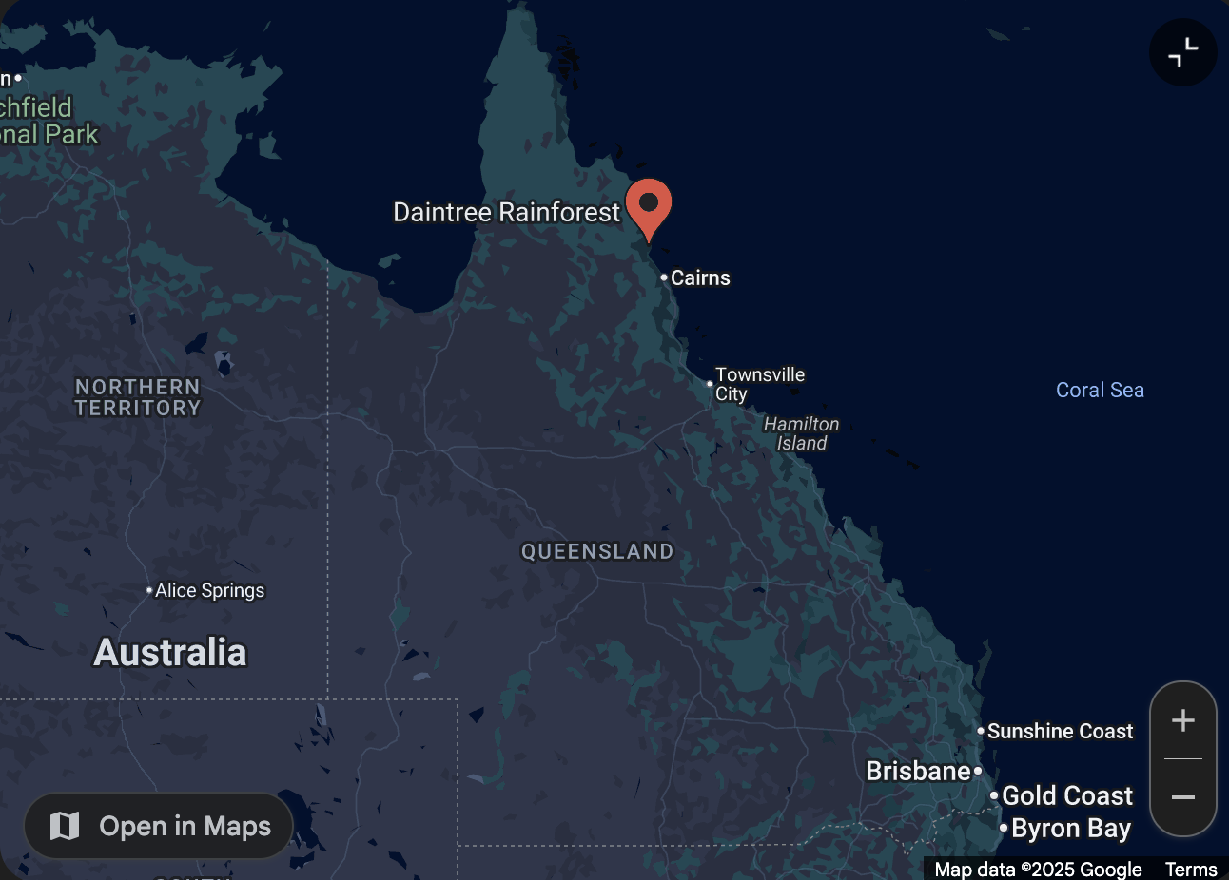
- What the Daintree rainforest looks like: It has a river called the Daintree River there also is several waterfalls including Mossman Gorge with its swimming holes and other well-known waterfalls like the Alexandra Bay waterfall

- How the Daintree Rainforest was made: The Daintree Rainforest formed over millions of years through a combination of geological uplift and sustained favourable climatic conditions.

- Why the Daintree rainforest is important to Australia? The Daintree rainforest is consisted as the world’s oldest tropical rainforest it is estimated to be 135 million years old, with incredible biodiversity and a unique mix of primitive and modern flora and fauna.

- Is there indigenous significance in Daintree Rainforest? Yes, the Daintree rainforest holds profound indigenous significance for the eastern kuku Yalanji people.

- Some of the Animals that live in the Daintree rainforest are southern cassowary, Boyd’s Forest Dragron, Daintree River ringtail possum, musky rat-kangaroo, estuarine crocodile, Ulysses butterfly plants that are in the Daintree rainforest: fan palm, Atherton oak, brown pine, king ferns.

- interesting facts about the Daintree Rainforest: The world’s oldest tropical rainforest is the Daintree Rainforest it is estimated to be around 135 million years old.

